Homework#4 [10 points]

COP 3813 Fall 2017

© 2017 Saeed Rajput, Ph.D.

To prove that you have completed all activities in this homework, do not forget to take a snapshot of your screen that clearly includes a view of your FAU username or e-mail address.

You can save this Homework file as MS-Word file (File->Download As->Microsoft Word (.diocx)) and provide answers within that document. All images, must be enclosed within a single WORD file. Homeworks submitted in multiple files will not be graded. Do not remove any original content from the file when editing the file to provide your responses.

# Problem 1 ([Class Video](https://fau.mediasite.com/Mediasite/Play/1eb64408749c4dd0b9449d45fe485fff1d?catalog=421bd4ed-0824-4957-9836-f05ea310d7d6)) [8 points]

1. Demonstrate that you can login into your lamp account using command line interface through SSH access. (provide a screenshot) [1 point]
   1. You can use putty (on windows) or Terminal window (MAC)

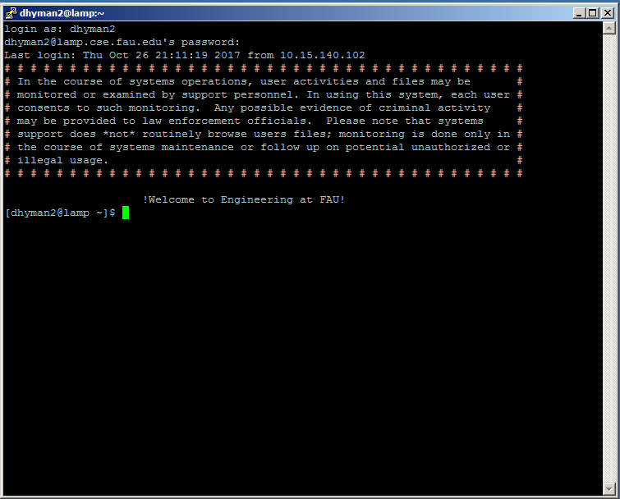

1. Demonstrate that you can login into mysql account on command line[1 point] (provide screenshot)
   1. If you have not already changed the password, change the password.

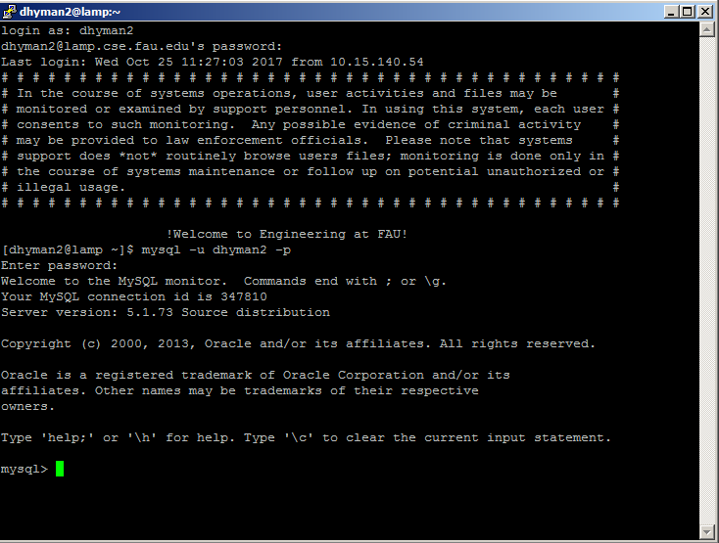

1. Modify the .my.cnf file as demonstrated in the class by setting your new mysql password (do not take a screenshot of the password, instead demonstrate that you can login into your mysql without the -p option. [1 point] (provide screenshot)

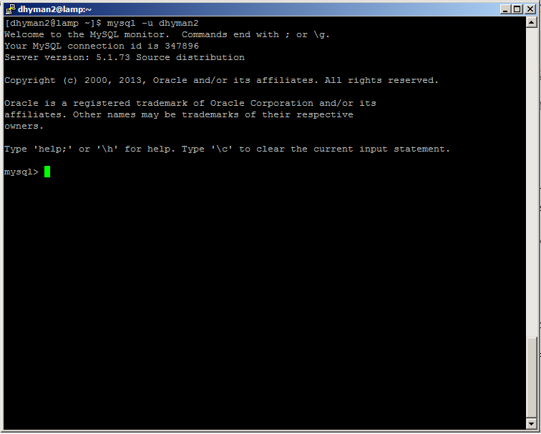

1. Create a table on your Lamp account that is related to your company (The same company that you have been working with in Project 1, 2 and 3). Demonstrate that you have table in the database. [2 point]
   1. Copy-n-paste the commands you used for creating and for displaying the table and provide a screenshot of the response from mysql.

Create table Members(Mem_ID integer, FirstName varchar(30), LastName varchar(30), Birthday date, SSN varchar(9));

* 1. The table must have at least four fields. [1 point]

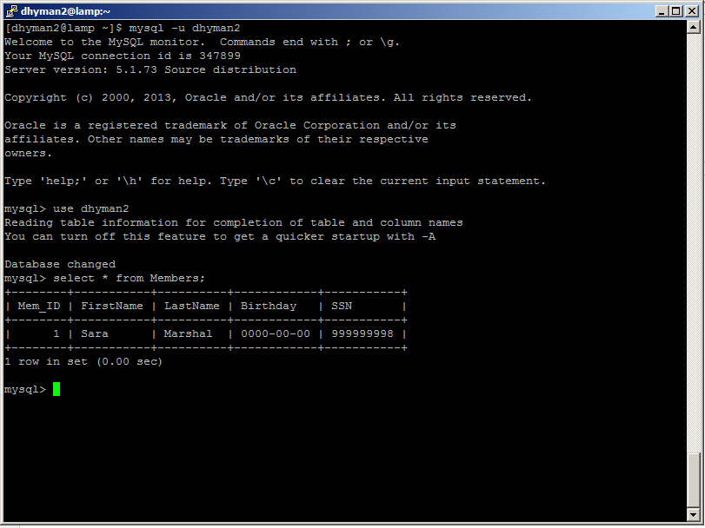

1. Add at least five entries into your table and show that you can display the complete table on command line. [1 point]
   1. Copy-n-paste the commands you used for adding and for displaying the entries into table and provide a screenshot of the response from mysql.

* Adding entries- Insert into Members values(1, ‘Sara’, ‘Marshal’, ‘1980-05-15’, ‘999999999’); 🡪 (The other four insert commands are shown with the screenshot below)
* Displaying the entries- Select * from Members;

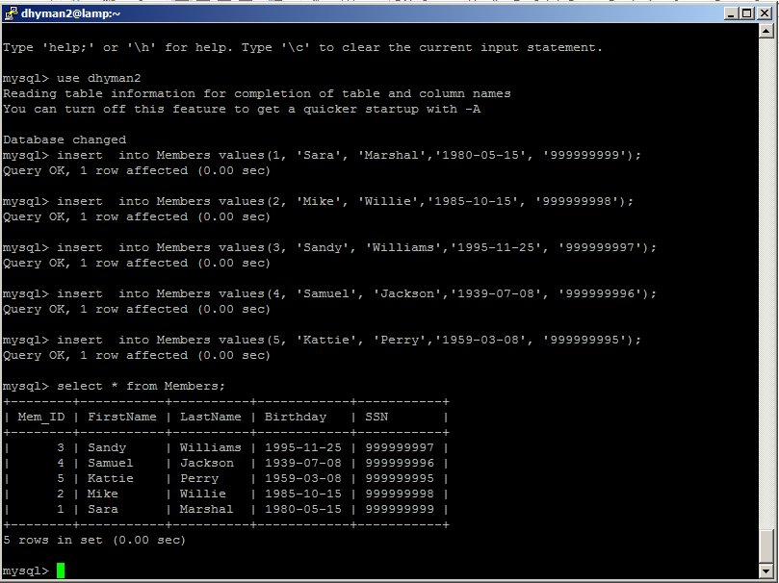

1. Write SQL queries to find entry (ies) in the table based on values of at least two different fields (one field at a time. You will have two queries). [1 points]
   1. Copy-n-paste the commands you used for adding and for displaying the entries into table and provide a screenshot of the response from mysql.

* Select * from Members where FirstName = ‘Kattie’; 🡪(The other query command is shown with the screenshot below).

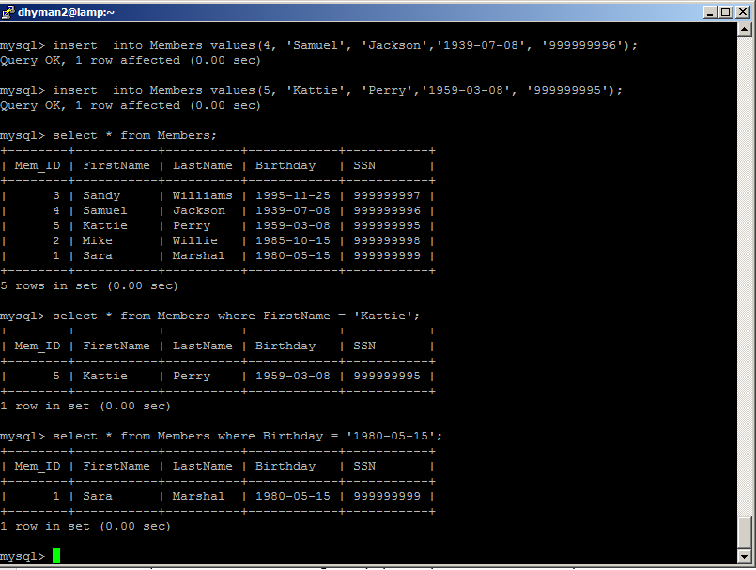

# Problem 2 (Using phpMyAdmin) [min 2 points]

1. Demonstrate that you can log into your phpMyAdmin by capturing a snapshot of screen when you are in. [2 points]

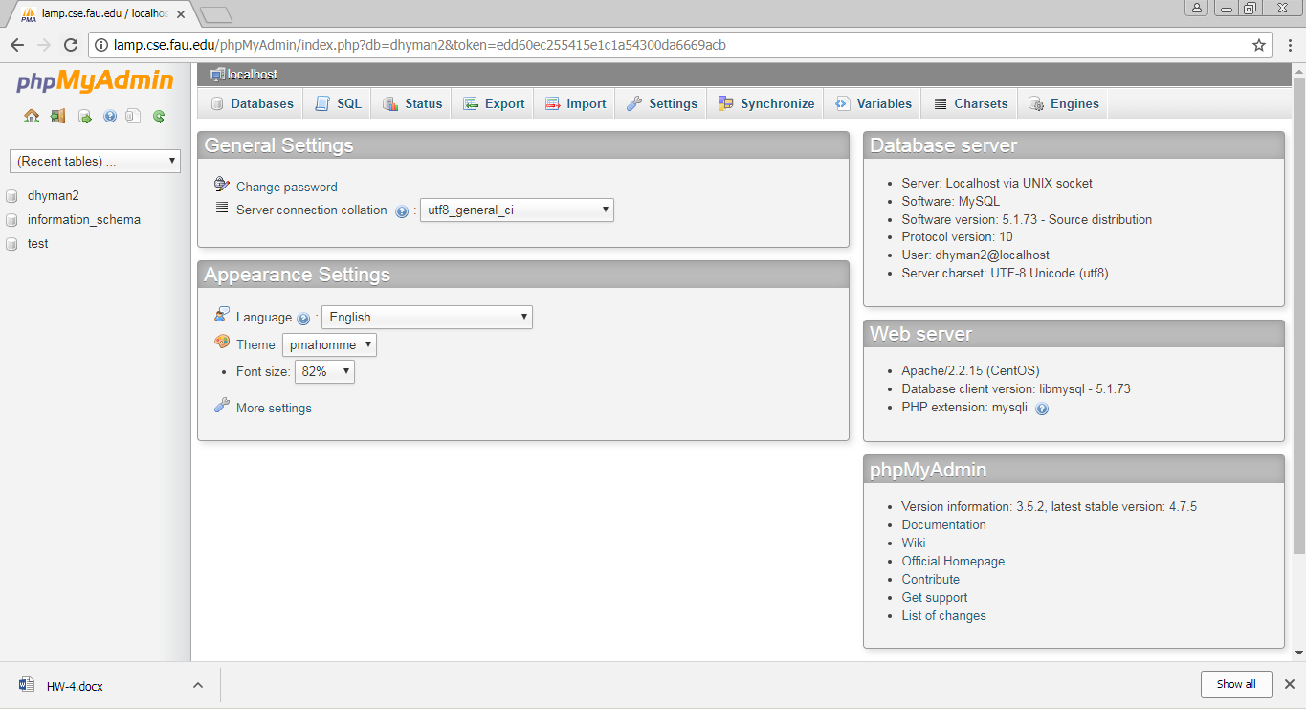

1. BONUS: Repeat Problem 1 but using phpMyAdmin interface while using a new table. (DO not delete the old table. Think of a new problem) [2 points]

## FAQs about this Homework:

(HW related questions that do not belong to any specific problem above can be posted below as comments below. Highlight an available number and place your question as comment See example 1 below).

Question 1

Question 2

Question 3

Question 4

Question 5

Question 6

Question 7

Question 8

Question 9

Question 10